Physics – ATAR Year 11 Unit 2

Test 1.2: Linear Motion and Forces

**Assessment type:** Test

**Task weighting**

4% of the school mark for this pair of units

Time allowed: 50 minutes

You may refer to the Formulae and Data booklet.

____________________________________________________________________________________________________

**Name** ________________________________ **Total: _______ /47 marks**

**Date** ________________________________

Show all working for your calculations, and express answers using appropriate units and significant figures.

**SECTION 1: SHORT ANSWER (13 Marks)**

1. **(3 marks)**

From the graphs represented below, select the appropriate graph(s) which describe(s) each of the following situations: (s = displacement, v = velocity, t = time).

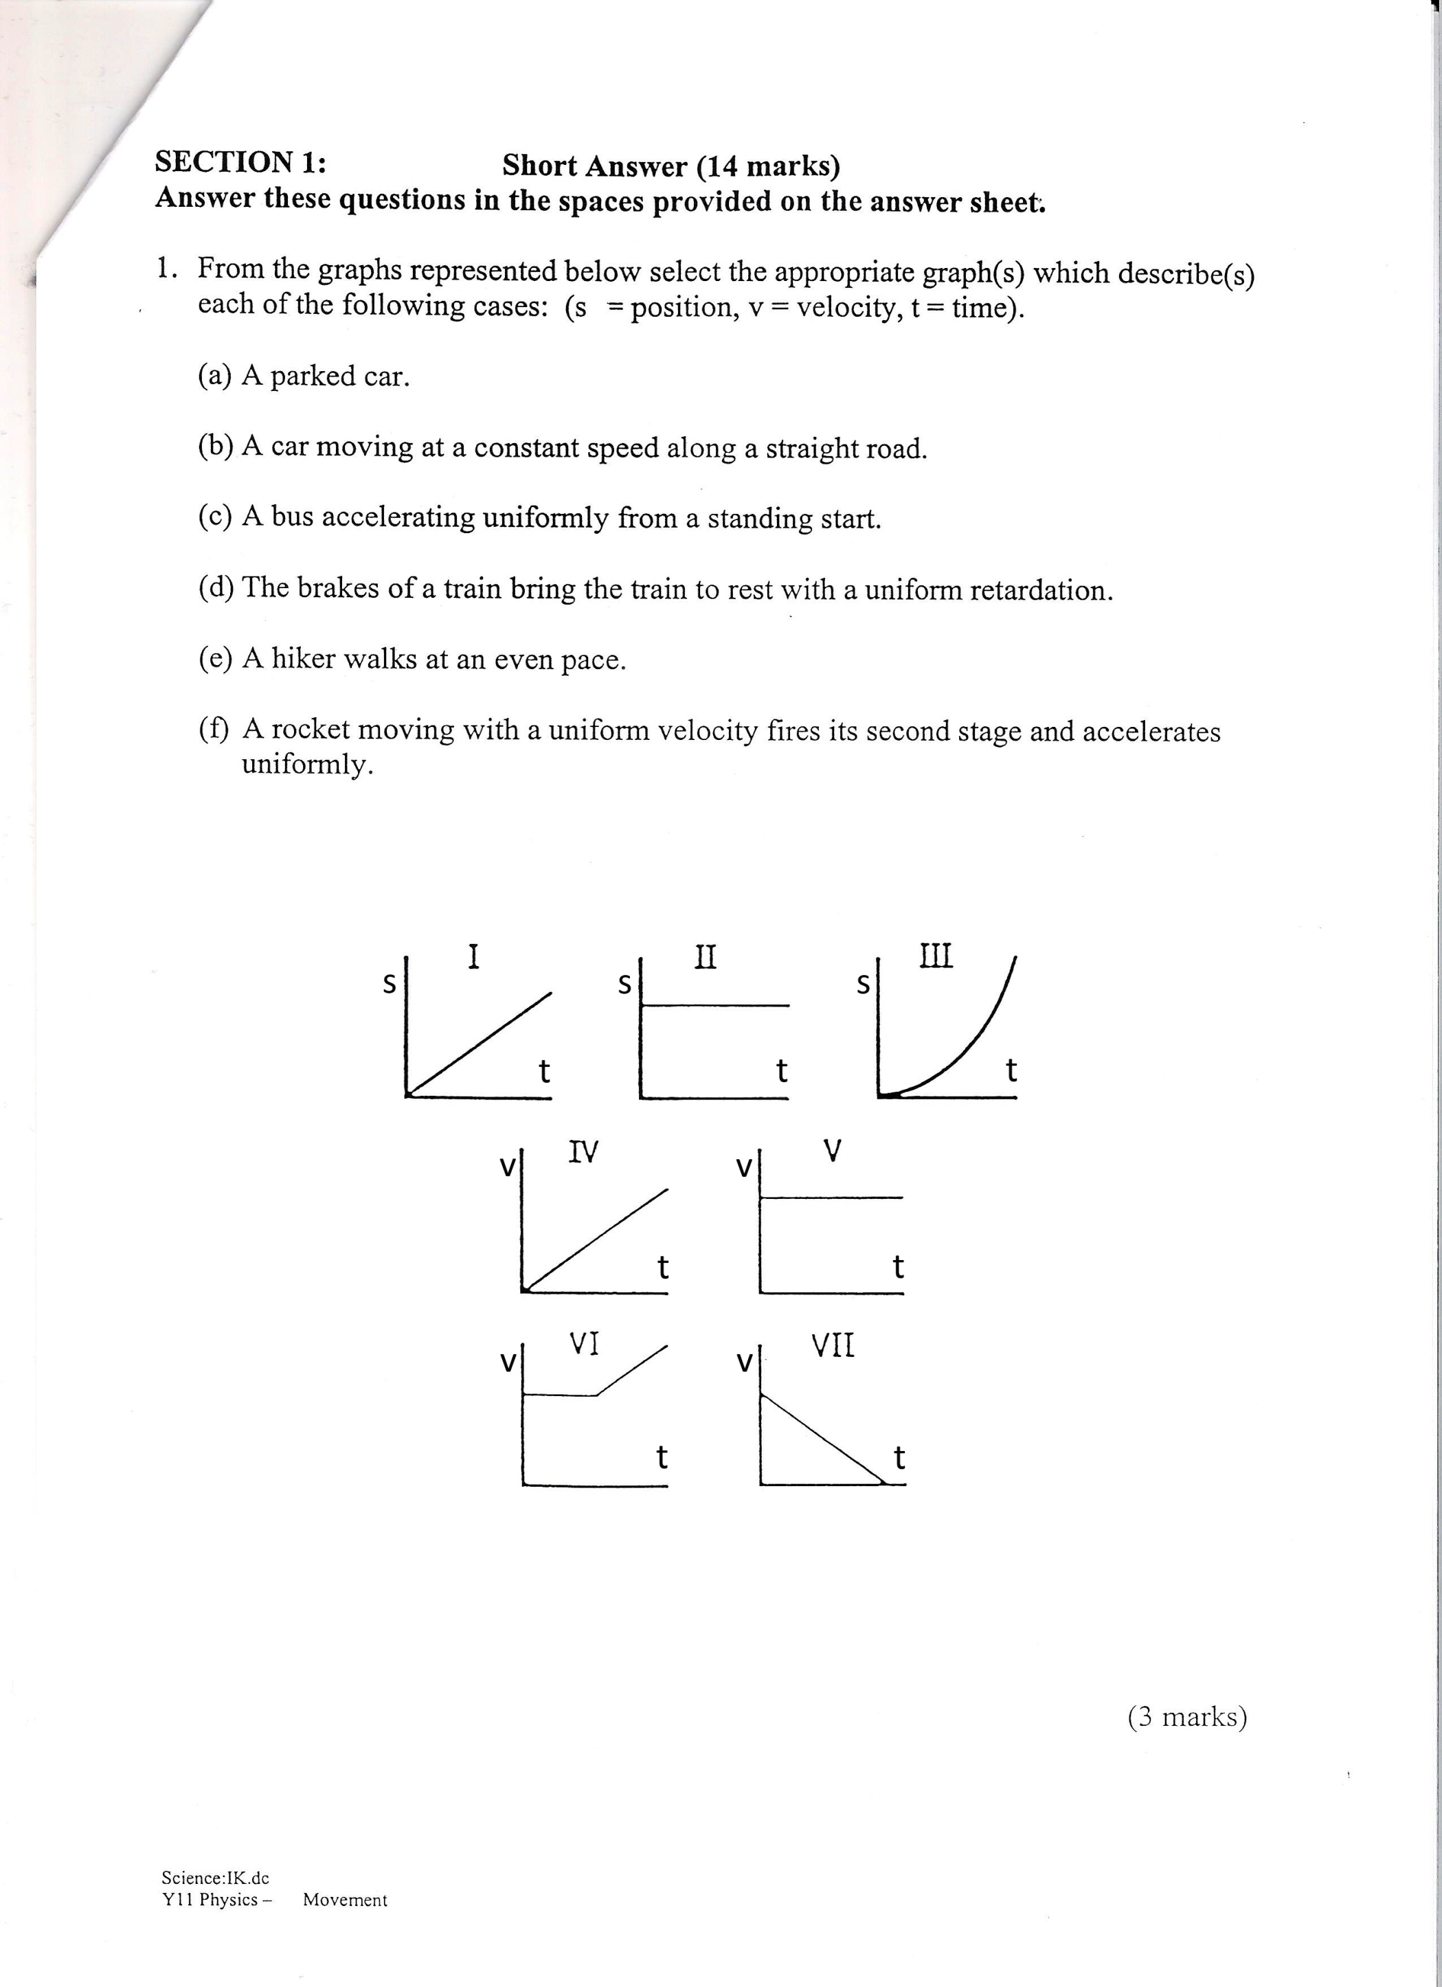

1. A parked car.
2. A car moving at a constant speed along a straight road.
3. A bus accelerating uniformly from a standing start.
4. The brakes of a train bring the train to rest with a uniform deceleration.
5. A hiker walks at an even pace.
6. A rocket moving with a uniform velocity fires its second stage and accelerates uniformly.
7. **(4 marks)**

Adam and Blake are pulling on a cart with forces of 150 N North and 180 N South respectively.

1. Draw a labelled vector diagram for this situation. (2 marks)
2. Calculate the resultant force. (2 marks)

1. **(3 marks)**

A bullet has a mass of 4.2 g and a velocity of 965 ms-1. An African elephant has mass 6000 kg and a velocity of 0.5 ms-1. Which would be harder to stop? Support your answer using calculations.

1. **(3 marks)**

A driver places a large box in the middle of the tray of a delivery truck. The box is not tied down.

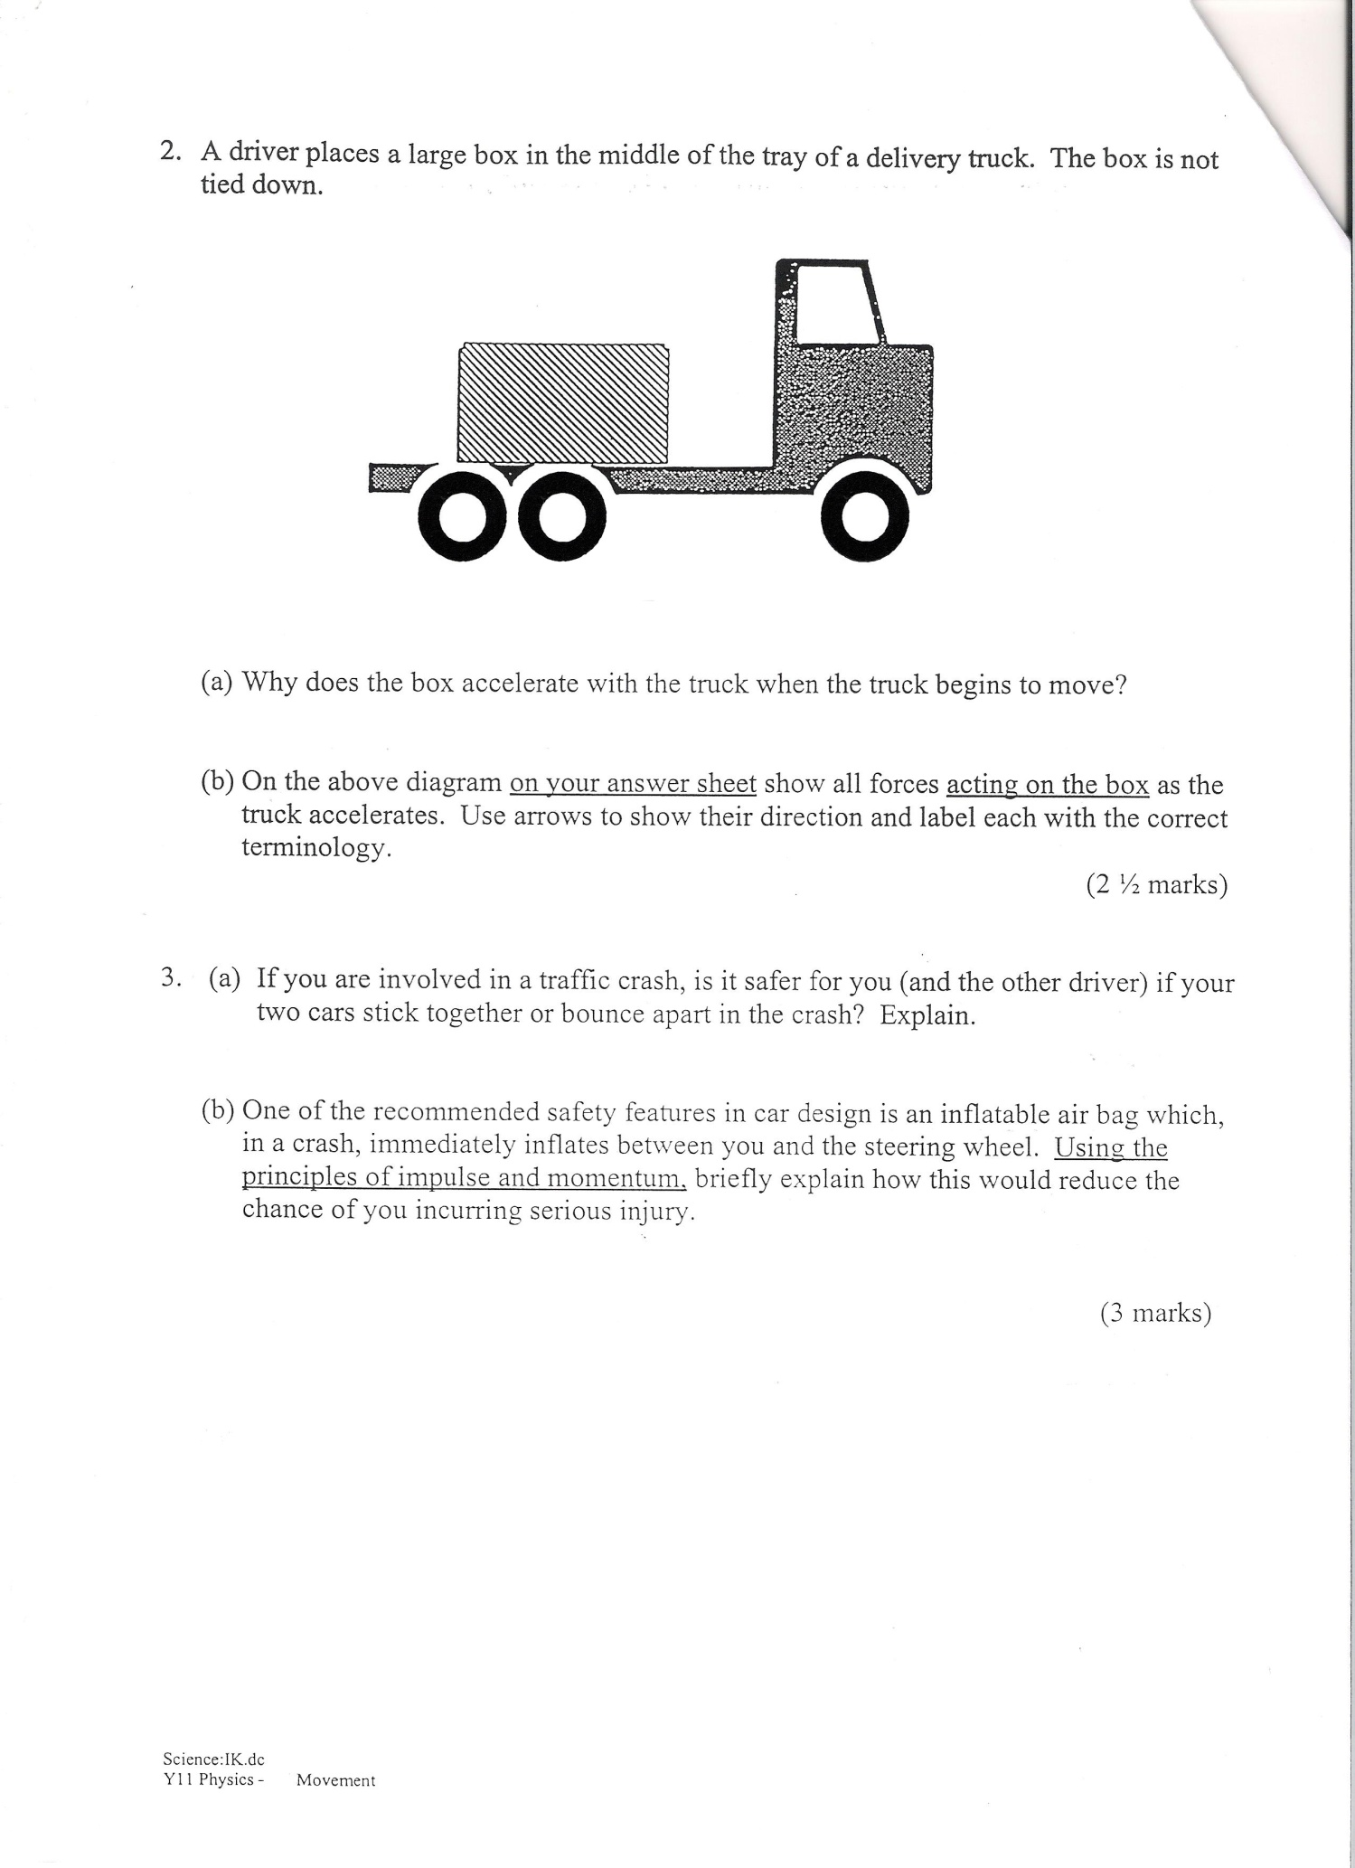

1. Why does the box accelerate with the truck when the truck begins to move? (1 mark)
2. On the diagram above, show all forces **acting on the box** as the truck accelerates. Use arrows to show their direction and label each with the correct terminology. (2 marks)

**SECTION 2: PROBLEM SOLVING (28 Marks)**

1. **(13 marks)**

A railway wagon of mass 1.00 x 102 kg travelling at 5.00 ms-1 strikes a second wagon of mass   
2.00 x 103 kg travelling in the same direction at 2.00 ms-1. They couple together and continue moving.

1. At what speed do they continue moving? (5 marks)
2. Calculate the amount of kinetic energy of motion that is changed into other forms of energy in the collision. (6 marks)
3. Into what forms of energy has the kinetic energy changed? (2 marks)
4. **(15 marks)**

Two boys are experimenting to find the depth of an old mine shaft, dropping a stone down the shaft and measuring the time taken for the stone to make a splash which they can observe in the water at the bottom. They find that 3.50 s is a good average time taken for the stone to fall from the top into the water. Calculate:

1. The depth of the mine. (3 marks)
2. The speed at which the stone strikes the water. (3 marks)
3. The time taken for the stone to hit the water if it was thrown with an initial velocity   
   of 25.0 ms-1 downwards. (3 marks)
4. The time taken for the stone to hit the water if it had been thrown upwards at 25.0 ms-1. (6 marks)

**SECTION 3: COMPREHENSION (6 Marks)**

**Read the following sports article and answer the questions below.**

**The Shark’s Swing is a meeting of grace, power and pure physics**

Source *The Age,* Friday 13, 1987

By SALLY WHITE, And BRENDAN MOLONEY,

science editor golf writer

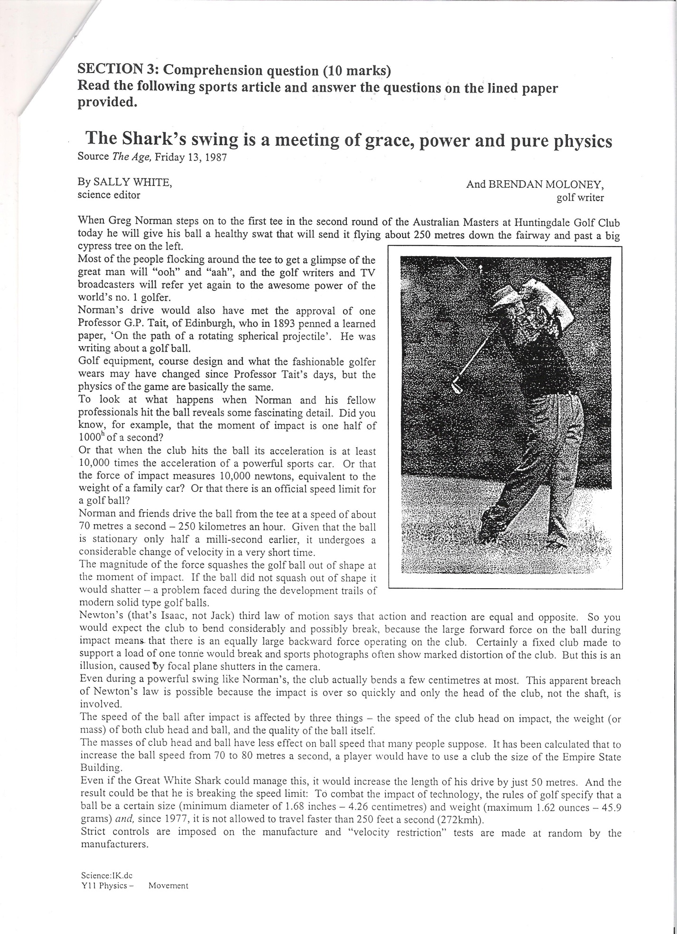

When Greg Norman steps on to the first tee in the second round of the Australian Masters at Huntingdale Golf Club today he will give his ball a healthy swat that will send it flying about 250 metres down the fairway and past a big cypress tree on the left.

Most of the people flocking around the tee to get a glimpse of the great man will “ooh” and “aah”, and the golf writers and TV broadcasters will refer yet again to the awesome power of the world’s no. 1 golfer.

Norman’s drive would also have met the approval of one Professor G.P. Tait, of Edinburgh, who in 1893 penned a learned paper, ‘On the path of a rotating spherical projectile’. He was writing about a golf ball.

Golf equipment, course design and what the fashionable golfer wears may have changed since Professor Tait’s days, but the physics of the game are basically the same.

To look at what happens when Norman and his fellow professionals hit the ball reveals some fascinating detail. Did you know, for example, that the moment of impact is one half of 1000h of a second?

Or that when the club hits the ball its acceleration is at least 10,000 times the acceleration of a powerful sports car. Or that the force of impact measures 10,000 Newtons, equivalent to the weight of a family car? Or that there is an official speed limit for a golf ball?

Norman and his friends drive the ball from the tee at a speed of about 70 metres a second – 250 kilometres an hour. Given that the ball is stationary only half a milli-second earlier, it undergoes a considerable change of velocity in a very short time.

The magnitude of the force squashes the golf ball out of shape at the moment of impact. If the ball did not squash out of shape it would shatter – a problem faced during the development trails of modern solid type golf balls.

Newton’s (that’s Isaac, not Jack) third law of motion says that action and reaction are equal and opposite. So you would expect the club to bend considerably and possibly break, because the large forward force on the ball during impact means that there is an equally large backward force operating on the club. Certainly a fixed club made to support a load of one tonne would break and sports photographs often show marked distortion of the club. But this is an illusion caused by focal plane shutters in the camera.

Even during a powerful swing like Norman’s, the club actually bends a few centimetres at most. This apparent breach of Newton’s law is possible because the impact is over so quickly and only the head of the club, not the shaft, is involved.

The speed of the ball after impact is affected by three things – the speed of the club head on impact, the weight (or mass) of both club head and ball, and the quality of the ball itself.

The masses of club head and ball have less effect on ball speed than many people suppose. It has been calculated that to increase the ball speed from 70 to 80 metres a second, a player would have to use a club the size of the Empire State Building.

Even if the Great White Shark could manage this, it would increase the length of his drive by just 50 metres. And the result could be that he is breaking the speed limit: To combat the impact of technology, the rules of golf specify that a ball be a certain size (minimum diameter of 1.68 inches – 4.26 centimetres) and weight (maximum 1.62 ounces – 45.9 grams) *and*, since 1977, it is not allowed to travel faster than 250 feet a second (272kmh).

Strict controls are imposed on the manufacture and “velocity restriction” tests are made at random by the manufacturers.

**QUESTIONS:**

1. In what time does the force of the golf club act on the ball? **(1 mark)**
2. What was the problem during the development trials of modern solid-type golf balls, explain why this happened, and explain why golf balls are elastic. **(3 marks)**
3. State Newton’s Third Law in your own words from that given in paragraph 8. **(1 mark)**
4. What is the reason given by the author for the shaft not breaking when the club makes contact with the golf ball? **(1 mark)**